**Topic 2: Private Equity**

Private Equity Market Landscape

 Note: “PE Landscape. O’Keefe.”

* Buyout funds
* Carried interest
* General Partner
* Limited Partner
* Mezzanine funds
* Net asset value (NAV)
* J-curve
* Venture capital (VC) funds

**1. Compare and contrast buyout funds with venture capital funds.**

Buyout Funds:

* Buyout funds invest in established businesses (generally privately held or spin-offs from public companies) that need financial capital in connection with a change of ownership.
* Invest in established businesses that require capital for changing ownership, either because they were privately held or because there was a spinout from a public company.
* Buyout funds are typically heavily leveraged. More measurable risk. Less sensitive to public equity markets.
* Buyout is a generic term that comprises management buyouts (MBO), where the current management acquires the company; management buy-ins (NBI), where new managers come from outside the company; and public--- to private transactions where companies are de-listed when a private equity company acquires their shares.

Venture Capital Funds:

* Invest in early-stage or expansion stage companies that are trying to gain market share in a new or high growth industry
* Riskier. Few winners and many write offs.

**2. Describe the relationship life cycle between limited partners and general partners.**

* General partners: the managers. Could be different depending on the fund.

Carried Interest:

A share of any profits that the general partners of private equity and hedge funds receive as compensation, despite not contributing any initial funds. This method of compensation seeks to motivate the general partner (fund manager) to work toward improving the fund’s performance

* Limited partners: investors with little or no influence on the day-to-day management of the fund. The interest of the limited partners is aligned with those of the general partners though a shared financial commitment to the fund, including the carried interest (or profit share) of the manager.

THE LIFE CYCLE

1. Entry and Establish phase – GPs have a hard time raising funds at this stage
2. Build and Harvest phase – Limited partners become more loyal to general partners
3. Decline or Exit phase – The fund is oversubscribed/large. Limited partners may leave. This phase has the lowest barriers to entry.

**3. Describe the J-curve.**

* The term J-curve is used to describe the typical trajectory of investments made by a private equity firm.

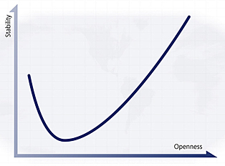

Routes into Private Equity



* Commitments
* Contractually limited life
* Distributions
* Drawdown
* Fundraising cycle
* Hurdle rate or preferred return
* Investment period
* Limiting liability
* Limited Partner
* Management fees
* Secondary transactions

**1. Identify key characteristics of PRIVATE equity funds and private equity Funds-of-Funds.**

PE funds have three advantages:

1. Limited Liability
2. TAX
3. Transparency

Key characteristics include:

* Limited Partners
* Limited life
* Management fees
* Capital calls
* Additional funding
* Distributions
* Secondary transactions
* Carried interest
* Fundraising cycle

Fund-of-Funds

Three types of transactions:

1. Core Portfolios
2. Private Equity Investments
3. Secondary private equity markets

**2. Discuss the value added and costs of using a private equity Fund-of-Funds structure relative to an in-house private equity investment program.**

Benefits of Fund-to-Funds

* Outsourcing expertise in fund selection
* Diversification
* Immediate access to high quality private equity partnerships
* Incentive structure

Drawbacks of Fund of Funds

* Management Fees
* Loss of Control

Private Equity Funds Structure

 Note: “Tube structure”

* Bad-leaver clause.

Someone who leaves (leaver) – but, is not very good and will not get a good payout.

* Carried-interest split: Split between the GP and the LP’s
* Clawbacks
* Distribution waterfall
* Good-leaver clause (without cause): cease funding the partnership with a vote requiring a qualified majority – generally more than 75% of the limited partners.
* Key person provision. Allows Limited Partners to suspend contributions and investment/divestment activities until a replacement is found.
* Limited Partnership Agreements (LPA): defines its legal framework and its terms and conditions
* Qualified majority: Generally, more than 75% of the limited partner
* Catch-up: is the time for the General Partner to be paid to catch up with the Limited Partners

**1. Describe how limited partnership agreement terms are designed to align the interests of private equity market participants.**

Limited Partnership Agreement (LPA) defines its legal framework and its terms and conditions for all parties involved with the fund. It addresses allocation of capital.

* Key Person Provision
* For-Cause Removal (Bad Leaver) Clause
* Without Cause Removal (Good Leaver) Clause. Needs qualified majority. 75%.

The Investment Process

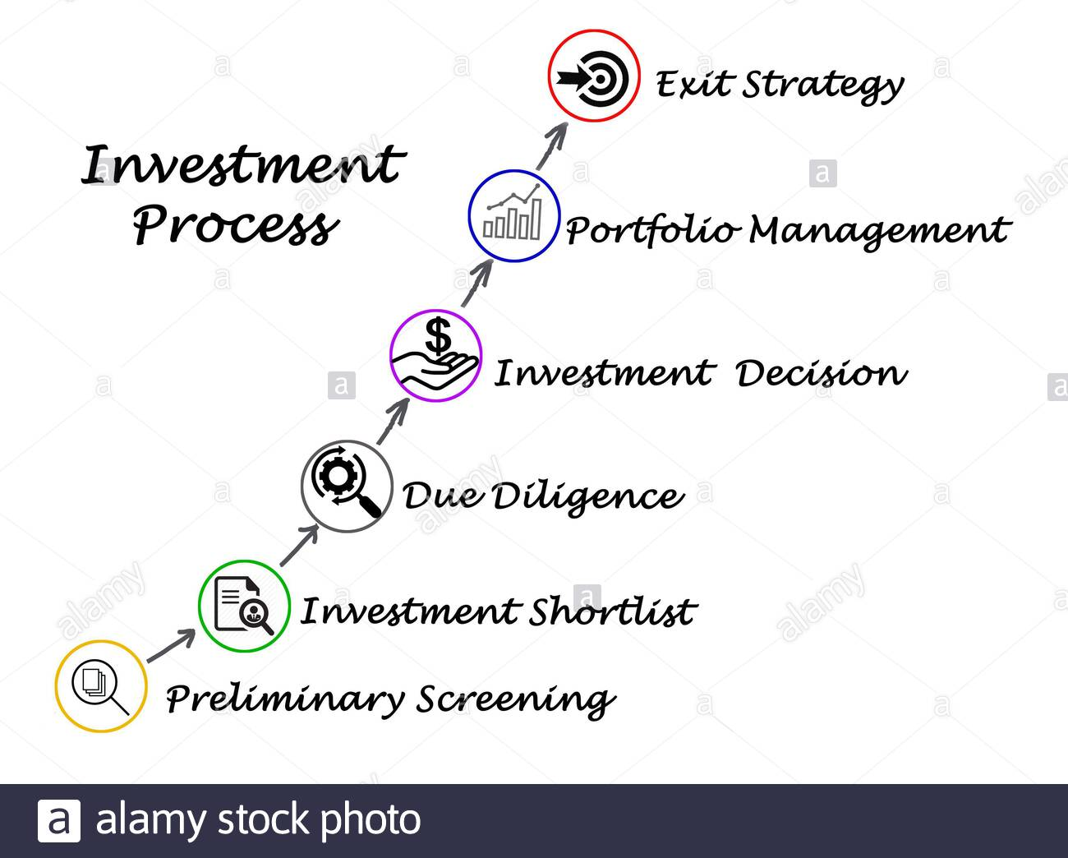

* Naïve allocation
* Overcommitment ratio
* Over-commitment strategy
* Vintage years

**1. Identify 3 key performance drivers for private equity.**

1. Portfolio Design
2. Management of liquidity aka (Commitment)
3. Fund Manager Selection.

**2. Describe the primary steps in the investment process and the rationale for each. ESSAY**

1. Portfolio objectives
2. Portfolio design
3. Liquidity Management
4. Fund Selection
5. Monitoring
6. Actions and implementation

**3. Describe the three pillars of risk management of private equity portfolios.**

**MCM.**

1. Measurement

Valuation of funds. Using discounted cash flow analysis. Use DCF instead of relying on the firm’s accounting.

1. Control

There is no definitive risk-adjusted pricing for primary equity fund investing.

1. Mitigation

Risk cannot be avoided entirely. There are overdraft facilities. Securitization. Some guarantees. Risk sharing through relationships.

Naive allocation: Essentially, when asked to make several choices at once, people tend to diversify more than when making the same type of decision sequentially.

Private Equity Portfolio Design pg. 39

Core-Satellite.

* Bottom-up approach
* Core-satellite approach
* Cost-averaging approach
* Market timing approach
* Mixed approach
* Naïve diversification

**1. Differentiate between a bottom-up, a top-down and a mixed approach to constructing a private equity portfolio.**

* Bottom up: Start with Managers

Begins with researching fund managers for all investment opportunities and choosing the best managers.

* Top Down: based on researching strategies and determining allocation ranges. MACRO – industry sectors, countries, and fund style that are best for the likely scenarios.
* Mixed Approach: Bottom up + Top down.

**2. Compare the core-satellite approach to diversification approaches for managing risk in private equity portfolios.**

* Core-satellite approach to allocating portfolio assets combines a large well-diversified core layer of assets (that reduces risk), with a smaller satellite layer that uses niche strategies to increase return through investments with large upside potential.
* Basically, like two layers. Core layer and a satellite layer.

**3. Explain the rationale for using NAÏVE diversification in the private equity markets.**

Naïve diversification is the optimal strategy when there is no information that allows differentiation among assets.

1. Vintage year diversification
2. Sector diversification
3. Stage diversification

**4. Compare market timing with cost-averaging in the private equity markets.**

* Cost averaging (Consistent investing) is a method of vintage year diversification which consistently invests a fixed amount of money throughout all years and steadily commits to the best funds around. Note: Consensus is that cost averaging does not work.
* Market timing involves varying investment levels across vintage years in an effort to invest more in years with better prospects and less in years with inferior prospects.
* Market timing can cause vintage year concentration.

Fund Manager Selection Process pg. 49 Big Book



* Private equity grading

**1. Describe the PE fund selection process. ESSAY**

1. Determine wish list
2. Deal sourcing
3. Due Diligence
4. Decision and Commitment

**2. Describe trends in private equity with respect to gaining access to top funds.**

1. Median private equity returns tend to underperform public equity indices.

PUBLIC fund returns > PRIVATE fund returns

1. There is a wider GAP between PRIVATE top quartile and bottom quartile returns than for PUBLIC funds of quoted assets.

PRIVATE GAP > PUBLIC GAP

**3. Discuss the importance and limitations of due diligence in fund manager selection**

* Limitations to picking managers:
* The high reliance on qualitative aspects and judgment can become a liability. Lack of suitable comparable and information makes the analysis highly subjective.

**4. Describe the steps of the due diligence process.**

1. Screening
2. Meeting the Team
3. Evaluation
4. Final and LEGAL Due Diligence

Benchmarking in the Private Equity World

* Bailey criteria – grouping of characteristics
* Benchmarking
* Commitment weighted
* Distribution to paid in-ratio (DPI)
* Interim internal rate of return (IIRR)
* Public market equivalent (PME)
* Residual value to paid-in ratios (RVPI)
* Survivorship bias
* Total value to paid-in ratio (TVPI)

**1. Discuss private equity benchmarks in the context of the Bailey criteria for appropriate investment benchmarks.**

Bailey Criteria – is the grouping of characteristics. Used for Benchmarks.

* Unambiguous/knowable
* Investable
* Measurable
* Specified in advance (pre-specified)
* Appropriate

**2. Calculate the following Performance Measures and discuss their drawbacks: interim internal rate of return (IIRR), total value to paid-in ratio (TVPI), distribution to paid in-ratio (DPI), and residual value to paid-in ratio (RVPI).**

Drawbacks:

1. They do not take into Account the Time Value of money.
2. NAVS are quarterly
3. IIRR assumes that distributions are reinvested in IIRR

* IIRR: Interim-internal-rate-of-return. It is a rough estimate of IRR performance prior to fund liquidation and is the most widely accepted private equity performance measure. Includes the NAV in the terminal cash flow and just do a regular IRR with TI BAII Calculator
* DPI: (DPI, or realized return). Distribution-to-paid in ratio. Measures the cumulative distribution to investors relative to the total capital drawn from investors.

Just uses cash flows for the equation.

* RVPI: (RVPI or unrealized return). Residual-value-to-paid-in ratio. Measures how much of the investors’ invested capital is still tied up in the fund. Uses only the NAV.
* TVPI: Total-value-to-paid-in-ratio. Measures cumulative distribution to investors plus the total value of the unrealized investments. Realized + Unrealized DPI + RVPI

**3. Compare classical and other relative benchmarks VS. absolute benchmarks.**

Classical:

* Vintage, geographic, and stage focus of referred to as “peer-group” cohort.

Relative:

* Extended peer group
* Public Market Equivalent (PME). The goal of the public market equivalent methodology is to calculate a private equity equivalent public index return, which provides a basis for comparison. The PME terminal value is substituted for the NAV in the IIRR calculation.

Absolute benchmarks:

* Target rate of return of 30% or more.
* Or have a target expressed as a premium over public equity
* Finally, the performance can be measured against the absolute returns of the historical peer group cohort for all the vintage years or the mature ones.

**4. Compare the returns offered by the two private equity funds to those of public securities, calculating the GAP between the IIRR of each private equity (PE) fund and the public market equivalent (PME).**

* Public Market Equivalent (PME). The goal of the public market equivalent methodology is to calculate a private equity equivalent public index return, which provides a basis for comparison.
* The PME terminal value is substituted for the NAV in the IIRR calculation.

1. **Discuss performance measures for portfolios of funds relative to performance measures of individual funds. AGGREGATION of measures for individual funds.**

* Simple Average
* Median
* Commitment weighted average
* Pooled
* Monte Carlo Situations

Monitoring Private Equity Investments



* Special purpose vehicle (SPV)
* Style drift
* Transparency

**1. Outline the tradeoffs to consider when determining the appropriate amount of monitoring of private equity investments.**

* Dilute a fund manager’s responsibility
* Private equity is continually evolving
* Interfering too much through monitoring may inhibit the manager’s ability to react

**2. Outline the costs and benefits of style drift in private equity funds.**

Style drift is the tendency of GPs to deviate over time from their initially stated and agreed upon investment style.

Style Drift Costs:

* Inability of LPs to adjust holding
* Window dressing
* Take too few risks and fail to meet the return objective
* Financial risk to the fund itself
* Litigation

Benefits:

* Flexibility. Take advantage of new opportunities.

**3. Discuss issues surrounding information gathering and transparency in the private equity industry.**

* Positive:

Gives investors more info to make sound decisions

* Negative:

Give away secrets

**4. Describe two main exit routes prior to private equity funds’ maturity.**

1. Secondary transactions (2nd). Highly illiquid markets. Typically, secondary market transactions occur at a discount of 15% to 45% of the NAV of private funds.
2. Securitization (example: transfer the limited partnership share to a special purpose vehicle SPV to be included in a collateralized fund obligation CLO). SPV issues junior and senior notes and invests the proceeds from these notes into a private equity fund of funds.

**5. Outline potential actions for addressing private equity funds that receive a poor evaluation.**

* Do not commit to the follow-on fund.
* Reduce Size of the Fund.
* Reduce management Fees.
* Give money back.

Private Equity Fund Valuation

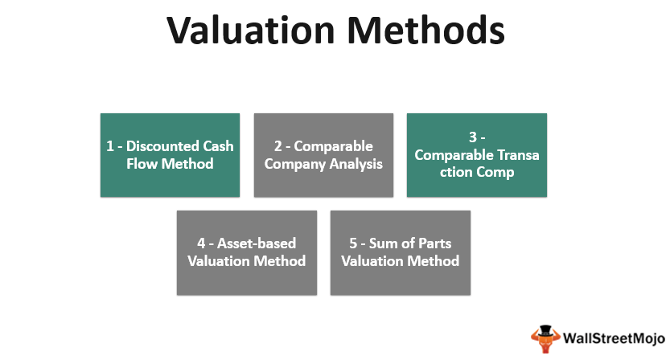

* Economic value approach
* Modified bottom-up approach
* Modified comparable approach

**1. Explain how private equity returns follow a J-curve.**

* At first, negative return – then it becomes positive.

**2. Argue for or against the use of the Net Asset Value (NAV) approach to value private equity funds.**

* NAV is often referred to as a residual value. It represents the value of all investments remaining in the portfolio, minus any liabilities and net of fees and carried interest as of a specific date.
* What about prospective earnings.

**3. Compare the Interim IRR (IIRR) to the traditional IRR.**

* The IIRR is the rate of return before the final termination date.
* IIRR – rough but widely used estimation of IRR. IIRR usually follows the J-curve.
* IIRR – is computed by taking the NAV as the last cash flow at time t.
* By following the J curve, most likely it will be higher than the IRR.

**4. Describe the three components of the Interim IRR (IIRR) in private equity investments.**

Past, Current, Future

1. Past cash flows
2. Current portfolio
3. Future cash flows

**5. Describe economic value approaches to private equity fund valuation.**

1. Modified top-down cash flow forecast:
   * Uses similar funds to compare
   * Requires that a fun’s IIRR and projected cash flows be determined
2. Modified bottom-up cash flow forecast:

* Primary performance drivers are identified
* Investment exits be estimated

Private Equity Fund Discount Rate



* Bottom-up betas
* Opportunity cost of capital

**1. Discuss the shortcomings of applying the Capital Asset Pricing Model (CAPM) to PE funds.**

* Liquidity Assumption: assumes all assets are liquid and no transaction costs
* Equal information assumption: assumes that all participants have the same level of information
* Market equilibrium assumption: assumes that markets are in equilibrium

**2. Defend the choice of a particular risk-free rate as an input to the CAPM for the purpose of estimating a private equity fund discount rate.**

* 6 to 8 years is standard equity fund. The risk-free rate should be similar in duration
* Should match the currency of the cash flow

**3. Defend the choice of a particular equity risk premium as an input to the CAPM for the purpose of estimating a private equity fund discount rate.**

* Moskowitz and Vissing estimated the private equity risk premium at least 4-5 % per yr.
* In the U.S., the premium estimated with historical data from 1926-2007 is 8.5%.
* Survivorship bias impacts private equity

**4. Describe various methods for estimating private equity (PE) betas.**

1. Quoted comparable
2. Use Relative Risk measurement technique
3. Estimating a bottom-up beta – uses unleveraged beta (on exam)
4. Modifying and correcting return data to estimate data

**5. Describe two alternatives to the CAPM for estimating private equity fund discount rates.**

1. WACC: The opportunity cost of capital. Rate of return expected by investors from publicly traded securities with similar risk.
2. COMPS: The historical performance of similar funds

The Management of Liquidity Big Book pg 98



* Distribution-in-kind
* Over commitment ratio

**1. Explain the over-commitment strategy by limited partners.**

* More commitments are signed than can be met with existing capital resources. An over commitment strategy of 140% is feasible.
* Over commitment ratio = signed commitments / resources available for commitments

= signed/resources

* The offsetting nature of these cash flows can result in an investor’s net investment at any one time being lower than the original commitment amount. Investors often try to manage their level of exposure to private equity and may employ an over-commitment strategy.
* Distributions-in-kind are payments made in an alternative format, such as property or stock, instead of cash. Companies and organizations use distributions-in-kind to minimize their tax liabilities and circumvent capital gains tax accruing from an increase in the asset's value.

**2. Identify seven sources of liquidity for private equity funds.**

1) Follow on funding

2) Liquidity lines

3) Maturing investments

4) Realizations of investments – you can sell investments to get liquidity

5) Sell-off of limited partnership shares

6) Distributions from private equity funds (Distribution-in-kind – stock instead of cash)

7) Limited partner default

**3. Compare and contrast various approaches to making CASH FLOW projections.**

* Estimation Approach
* Forecasting Approach: Has longest approach
* Scenario Approach

End Big Book

______________________________________________________________________________

The IRR

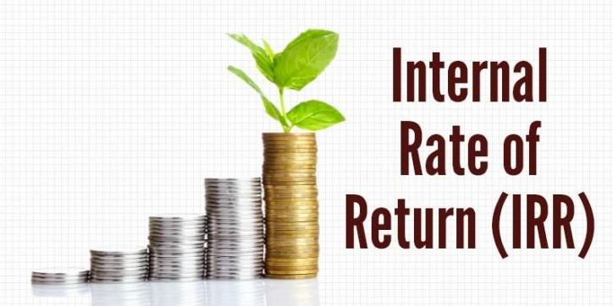

* Smell test
* Point-to-point IRR
* Time-Zero IRR

**1. Understand the reasons that the Internal Rate of Return (IRR) is an important measure of private equity performance.**

* IRR helps take into account both CASH and TIME weighted measurement

**2. Define the Internal Rate of Return (IRR) in words and as a formula.**

* IRR = Rate of return which sets NPV to zero

**3. Compute the mathematically correct IRR(s) for various sets of cash flows.**

****Calculator document

**4. Understand challenges of multiple IRR or misleading mathematically correct IRR solutions and explain how results may be interpreted.**

1. Sign of the cash flows changes from positive to negative multiple times + - + - +
2. There are large changes to the relative size of the cash flows

Smell test: test for reasonability

**5. Describe how an existing (positive or negative) IRR is affected by subsequent cash flows.**

* Positive existing IRR: early cash flows have bigger effect
* Negative existing IRR: later cash flows have bigger effect

**6. Understand challenges to using IRR with total loss of capital, with initial positive cash flows, in the aggregation of fund IRRs and in the ranking of funds.**

* All invested capital has been lost
* More than the invested capital has been lost
* Situation in which the 1st cash flow is positive

**7. Understand other measures related to IRR.**

* The Point-to-Point IRR: Measures the IRR between two date periods.
* Time Zero IRR: Start all the investments at the same date, and the time zero neutralizes the effect of the early winner.

Distribution Waterfall

* Carried interest
* Catch-up
* Clawback
* Distribution provisions
* Distributions-in-kind
* Floor
* General partner investment in fund
* Hard hurdle
* Hurdle rate
* Limitations
* Management fees
* Preferred return
* Soft hurdle
* Vesting

**1. Explain why the waterfall distribution is important.**

* The waterfall sets the rules and procedures for the distribution of profits
* LPs before the GPs.

**2. Discuss the following aspects of an incentive structure: management fees, amount of the general partner’s investment in fund, carried interest-split, vesting provisions, and distribution provisions.**

* Management Fees

Calculated as a percentage of the fund size.

* General partner’s investment in a fund
* Carried Interest Split

Carried Interest depends on the performance of the fund.

* Vesting Provisions

Denotes the process and timetable by which the managers are legally transferred their incentive payments.

* Distribution Provisions

Dictate the specific timing and provisions of the distribution of profits.

**3. Determine private equity fund profits on an aggregate and individual transaction basis.**

* The profit on an aggregate and individual basis may differ quite dramatically.

**4. Evaluate various Carried Interest schemes.**

1. Pure deal by deal carried interest
2. Pure fund as a whole carried interest

**5. Determine how proceeds are distributed and calculate the preferred return when provided appropriate terms and assumptions.**

* Preferred Return
* A preferred return is a profit distribution preference whereby profits, either from operations, sale, or refinance, are distributed to one class of equity before another until a certain rate of return on the initial investment is reached.

1. **Compute the breakeven IRR for two funds with different carried interest, catchup and hurdle rate provisions.**

* Carried interest
* Catch-up provisions: are key to the profit split. Only after managers are caught up will investors and managers split the carried interest.
* Hurdle rate provisions: Preferred Return.

See document:

* **First**, 100% of all cash inflows to the LP until the cumulative distributions equal the original capital invested plus some preferred return.
* **Second**, a "20% catch up" to the GP equivalent to 20% of the of the distributions realized in step 1 plus the distributions realized in this step.
* **Third**, thereafter, cash flows in excess of distributions made in step 1 and step 2 (if any) are distributed 80% to the LP and 20% to the GP.

**7. Compare the preferred return to a free option.**

* Distribution of the preferred return is similar to that of a call option.
* The GP will have unlimited upside and limited downside risk.

**8. Compare and contrast deal-by-deal and fund-as-a-whole carried interest distribution approaches.**

* Deal-by-Deal: the general partner will receive profit on each investment independent of the performance of other investments.

vs.

* Fund-as-a-whole: Calculates the carried interest on the performance of the entire fund which is more likely to align the interests of managers and investors.

**9. Determine the amount of clawback from the general partner when provided appropriate assumptions and parameters.**

* Goal of the clawback provisions in private equity fund partnerships agreements is to protect the economic split agreed between the general partner and the limited partner. Clawback is sometimes called a giveback.

**10. Discuss the limitations of clawback provisions.**

* Repay might be unenforceable
* GP may string out life of the investment
* Lawyers might be too costly

What Drives PE? Analyses of Success Factors for Private Equity Funds



* Buyout ratio
* Herfindahl-Hirschman Index

Concentration of the market! Used in Anti-trust cases.

* (HHI)
* Markov transition matrix
* Percentage loss
* Public market equivalent
* Vintage year

1. **Explain how and why the ENDOGENOUS factors such as region, industry sector, financing stage, vintage year, and general partner experience can impact the following private equity performance measures: IRR, public market equivalent and percentage loss.**

* IRR: Good public performance. IRR is high.
* Public Market Equivalent (PME): If the (PME) > 1 then the investment performs well.
* GP experience is good
* The term "vintage year" refers to the milestone year in which the first influx of investment capital is delivered to a project or company. This marks the moment when capital is committed by a venture capital fund, a private equity fund or a combination of sources.

**2. Explain how and why the EXOGENOUS factors such as public market performance, interest rates, and GDP growth can impact the following private equity performance measures: IRR, public market equivalent and percentage loss.**

* High interest rates NOT good
* Funds starting in periods of high GDP are NOT good

**3. Explain how Markov transition matrices are used to evaluate the GP’s performance persistence, and what Aigner, et al found using this methodology.**

* Markov indicates the past performers tend to perform well in the future

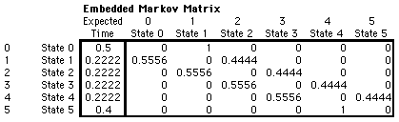

A Markov chain is a stochastic model describing a sequence of possible events in which the probability of each event depends only on the state attained in the previous event. A countably infinite sequence, in which the chain moves state at discrete time steps, gives a discrete-time Markov chain.

The Changing Face of Private Equity: How Modern Private Equity Firms Manage Investment Portfolios



**1. Compare and contrast the two private equity management models: the “Financial Investor” and the “Interventionist”**

* Financial Investor model is a passive management model focused on financial engineering.
* Interventionist model

**2. Describe the reported impact on the performance of the two private equity management models and argue whether active ownerships add substantial value to the investment portfolio of a private equity firm.**

* INTERVENTIONISTS ADD VALUE
* Interventionists had a higher alpha, Sharpe ratio, and Treynor ratio over both periods.

**3. Describe the 5 factors Interventionists share that may help them generate superior returns.**

* Acting as an active shareholder
* Align Interests
* Portfolio relatedness
* Avoiding COSTS
* Focusing on an EXIT strategy
* Treynor Ratio:

Beware of Venturing into Private Equity Ludovic Phalippou



Why is PE perceived to outperform public equity, when in reality the reverse appears to be true?

**1. Summarize the evidence on the Puzzle that private equity funds have provided LOW average returns.**

* Sample Bias -- only report good firms
* Valuation Bias -- accounting values could be stale
* Misuse of the IRR – is flawed measure for PE

**2. Describe typical compensation contacts and the various associated fees for private equity and buyout fund managers.**

* Management fees
* Portfolio company fees
* Carried Interest/Incentive fees
* Miscellaneous fees

**3. Compute the fees and the reported performance for a representative buyout firm.**

*** See book examples

**4. Illustrate how an investor cannot know in advance the quality and quantity of investment in which it will be invited to CO-INVEST, and the relationship between the outcome, the fees and the eventual return.**

* CO-INVESTING is only measurable after all fund and co-investment positions have been exited
* CO-INVESTING reduces Fees

**5. Discuss the following potential reasons behind investors’ misperceptions regarding expected payments by buyout funds:**

a. Variations within similar-looking fees

Similar but different fees

b. Shrouded negative internal rates of returns

Hidden negative IRRS

c. Shrouded accounting information and keeping losers at cost

d. Using flaws in the internal rate of return

e. Sample bias (good tracking records are shown more often)

f. Shrouded key details (duration, leverage, net-of-fees performance, and fee

details)

Private equity funds actively hide important performance details from investors.

**6. Discuss the following three features of buyout contracts that may lead to conflict**

**of interest:**

* + - 1. Carried interest & strategic timing of cash flows.

A GP tries to use the cash from early sales to invest and collect the FLOAT.

* + - 1. Incentives to exit early

Managers are incentivized to exit the successful deals to invest the cash. Improves the IRR.

* + - 1. Transaction fee incentives

More transactions mean more fees. Incentive to do a bunch of small deals.